Using Optoelectronics and Machine Learning as
a Personalized Approach for Online Monitoring Hemodialysis

Yao-Te Wang^{1*}, Yi-Ting Chen^{3,4*}, Wingates Voon⁷, Cheng-Che Hsu², Fong-Shung Huang^{3,4},
Shuei-Liong Lin⁴, Yu-Hsiang Chou⁴, Jyh-Shing Jang⁵, and Yen-Wen Lu^{1,6, **}

¹Department of Biomechatronics Engineering, ²Department of Chemical Engineering,
³Department of Integrated Diagnostics & Therapeutics, ⁴Renal Department of Internal Medicine,
⁵Department of Computer Science & Information Engineering, ⁶Institute of Biotechnology,
National Taiwan University, Taipei, Taiwan
⁷Department of Mechatronics and Biomedical Engineering, Lee Kong Chian Faculty of Engineering and Science, Universiti Tunku Abdul Rahman, Sungai Long, Malaysia

*Contributed Equally
**Corresponding author: yenwenlu@ntu.edu.tw
Abstract
Our study introduces an innovative methodology, acknowledging the essential demand for personalized and instantaneous monitoring of physiological data in patients undergoing hemodialysis (HD). We have refined our previously reported optoelectronic system that employs ultraviolet (UV) light-emitting diodes (LEDs) to measure absorbance, enabling the real-time tracking of toxin levels in patients’ blood. This enhanced approach utilizes machine learning (ML) algorithms, particularly the Support Vector Regression (SVR) model, to merge specific features from HD treatments and absorbance readings, thus improving the accuracy in predicting uremic toxin concentrations. In a series of thirty HD sessions involving nine patients with End-Stage Renal Disease (ESRD), our system has proven its predictive accuracy by establishing significant correlations between the estimated and actual concentrations of critical toxins, including urea nitrogen (R² = 0.953), creatinine (R²= 0.952), uric acid (R²= 0.959), β2-microglobulin (R²= 0.822), phosphorus (R²= 0.853), and potassium (R²= 0.621). Moreover, our analysis on feature selection has verified the indispensable role of absorbance readings from the optoelectronic system in assessing the HD process in real time. This system can potentially enhance conventional blood testing methods by providing continuous feedback on the effectiveness of the HD treatment and predicting possible complications. The fusion of optoelectronic technology with ML marks a significant leap forward in the management of HD, creating a pathway towards care that is both highly personalized and precise, thereby offering substantial improvements in patient outcomes.

Keywords: Online monitoring, absorbance/transmittance, quantitative analysis, personalized feature, hemodialysis assessment, uremic toxin, Beer’s Law

Introduction
Hemodialysis (HD) treatment plays a critical role in end-stage renal disease (ESRD) by eliminating harmful uremic toxins to sustain life. While traditional methods employ serum toxin analysis and the Kt/V ratio to provide baseline assessments, they often lack the detail analysis for patient-specific evaluations, which is crucial for optimizing therapy. Such personalized treatment evaluation and related strategies, which are tailored to each individual's clinical, molecular, and lifestyle specifics, highlight the growing emphasis on precision medicine in healthcare and the necessity heralding new possibilities in ESRD management [1-6].
Recent advancements in ESRD management for patient-focused care include the adoption of innovative biosensors for real-time monitoring of hemodialysis (HD) sessions [7-11]. These sensors facilitate ongoing observation of essential health metrics, revolutionizing the way ESRD treatments are administered. By integrating individual patient information and utilizing machine learning (ML) algorithms, the data from these sensors are enhanced to offer customized insights, allowing for the personalization of HD treatments in ways that traditional methods do not permit [12, 13]. This integration of cutting-edge biosensors with ML heralds a new era in precision medicine, creating opportunities for HD therapies to be efficiently and specifically adapted to meet the unique health requirements of each patient.
One of the advancements in recent patient-centered care for ESRD management has been the implementation of novel biosensors to real-time monitor the progress of the HD sessions [7-11]. These sensors enable the continuous tracking of vital health parameters, fundamentally changing the administration of treatments for ESRD patients. By including patients’ personalized information and anlyzed with machine learning (ML), these sensor data are complemented to provide personalized data and to further customize the HD treatments - a prospect not feasible with conventional approaches [12, 13]. This combination of advanced biosensors and ML defines a new phase in precision medicine, paving the way for HD therapies that are effective and uniquely tailored to each patient's health needs.
Meanwhile, HD has been recently benefited by the introduction of ML to ???has become increasingly popular in recent research endeavors. Numerous studies within this domain have concentrated on predicting adverse events and complications during HD sessions. These investigations delve into diverse aspects, such as the prediction of hypotension [14], water pump failures [15], and intradialytic adverse events [16], utilizing ML algorithms to enhance patient safety and mitigate complications. Additionally, a noteworthy focus lies on optimizing dialysis treatment through ML models for dialysis adequacy [17], blood flow volume [18], and hemoglobin levels [19]. Some studies have also aimed at addressing specific patient populations, including mortality risk prediction [20], the risk of intracerebral hemorrhage (ICH) in HD patients [21], and the risk of undetected SARS-CoV-2 infection in HD patients [22]. While a discernible research gap exists in the current literature regarding real-time monitoring of HD with ML, we aim to fill this gap by advancing HD care through real-time monitoring and ML, contributing to precision-oriented and individualized HD treatments.
Regarding the hardware employed in HD monitoring, previous endeavors utilizing ion concentration conductivity and electrochemical sensors encountered challenges of measurement stability and sensor longevity [14, 15]. For instance, ion concentration conductivity calculates ion concentration by measuring the concentration difference between the dialysate inlet and outlet [16-20]. The stability of the measurement environment limits this method, and the accuracy of the conductivity measurement of blood is affected by factors such as blood pressure or other molecular content [19]. In addition, conductivity cannot distinguish specific ion species but only approximates them as sodium balance substitutes [20]. The working principle of an electrochemical sensor is to convert the analyzed substances on the sensor into electrical signals through electrochemical reactions and to calculate the substance concentration through the signal. Urea sensors have been shown to provide relatively accurate urea concentrations [21, 22]. Nevertheless, urea sensors are limited by their durability [23] and can have surface passivation problems on the electrode attributed to the proteins, phenols, amino acids, and other biological molecules during HD [24]. Additionally, although similar sensing concepts have been developed for online monitoring, there are limitations on the types of molecules that can be measured by electrochemical sensors [25].
Absorption spectrophotometry, a non-invasive technique utilizing a spectrophotometer for multi-substance measurements, holds promise in monitoring spent dialysate [26]. As lightweight and affordable alternatives to spectrophotometers, Ultraviolet (UV) light-emitting diodes (LED) are employed, where the uremic toxins in spent dialysate are monitored while neglecting their concentration in patients’ blood [27-29]. To address the intricacies of HD monitoring, a new paradigm is needed, one that transcends the limitations of traditional methods and embraces the nuances of patient variability.
Vital indicators of dialysis adequacy and patient well-being encompass small and mid-size molecules, including urea, creatinine, and β2-microglobulin, along with essential electrolytes in the blood [30-36]. The heterogeneous nature and inter-patient variability of these biomarkers challenge the precision of current monitoring techniques, especially those dependent on single-wavelength assessments [28, 29, 37, 38]. Previous research has often been constrained when estimating uremic toxin levels through the absorbance at certain wavelengths, typically over a limited number of HD sessions. The reliability of these predictions tends to diminish when extended across numerous sessions and diverse patients [27, 38-40]. The unreliable predictions are attributed to HD treatment's individualized nature, wherein each patient possesses distinct physical characteristics, including height, body weight, dialysis vintage, and interdialytic period [41]. For example, individuals with greater height or body mass generally have a higher cellular mass, which can lead to increased generation of toxins like urea nitrogen, creatinine, and uric acid [42, 43]. Extensive periods of dialysis treatment suggest more compromised renal function, necessitating heightened toxin removal [44, 45]. A longer interdialytic period indicates higher uremic toxin levels [46, 47].
Furthermore, each session has different HD parameters, such as the membrane area of the dialyzer, blood flow, target ultrafiltration volume, and dialysate flow rate. For instance, a larger membrane area of the dialyzer allows for increased contact between the patient's blood and the dialysate, facilitating greater diffusion of solutes across the membrane. Higher blood flow enhances the efficiency of uremic toxins removal by facilitating greater diffusion across the dialyzer membrane [48]. Higher ultrafiltration volumes and a faster dialysate flow rate greatly increase uremic toxins clearance [49, 50]. The interplay of these individualized factors means that the accuracy of predicting toxin concentrations for various patients and sessions can be constrained. Hence, this study posits that the inclusion of individual characteristics not only enhances the precision of predictions on uremic toxin concentrations based on absorbance data alone but also serves as a valuable complement.
Our research enhances hemodialysis (HD) treatment by advancing our real-time optoelectronic monitoring system, as well as integrating with machine learning (ML) analysis. This system collects molecular data continuously during HD sessions. When combined with individualized factors such as body composition, dialysis experiences, and treatment frequencies, our approach offers enhanced precision in predicting a broader range of uremic toxins. This approach thus transforms patient care from periodic, static checks to a dynamic, continuous monitoring process, ensuring that HD treatments are not only tailored to immediate needs but also attuned to the prospective health outcomes of patients. In doing so, the study bridges the gap between traditional monitoring methods and the demand for individualized, precision-oriented HD care, aiming to tailor each treatment session to the distinct requirements of the patient.

Materials and Methods
This section details our methodology for monitoring uremic toxin levels during HD, encompassing key aspects such as wavelength selection, the innovative optoelectronic system, and essential clinical trial procedures. The selection of wavelengths at 255nm, 275nm, and 310nm is explained, grounded in the distinctive absorption characteristics of key uremic toxins. Following this, our optoelectronic system, which comprises three UV LEDs aligned with the selected wavelengths, a quartz flow cell, photodiodes, a relay, and a signal processing module, is introduced This system plays a critical role in precisely measuring absorbance and addressing challenges posed by overlapping absorption spectra while analyzing spent dialysate. Detailed schematics and specifications are presented, highlighting the significance of each component. Subsequently, we provide an overview of the clinical trial, detailing data collection and pre-processing procedures crucial for subsequent ML analysis using the SVR model. Finally, a key element of our methodology involves linear regression analysis, establishing a correlation between uremic toxin concentrations in spent dialysate and blood. The holistic flow of our methodology is depicted in FIG. 1.

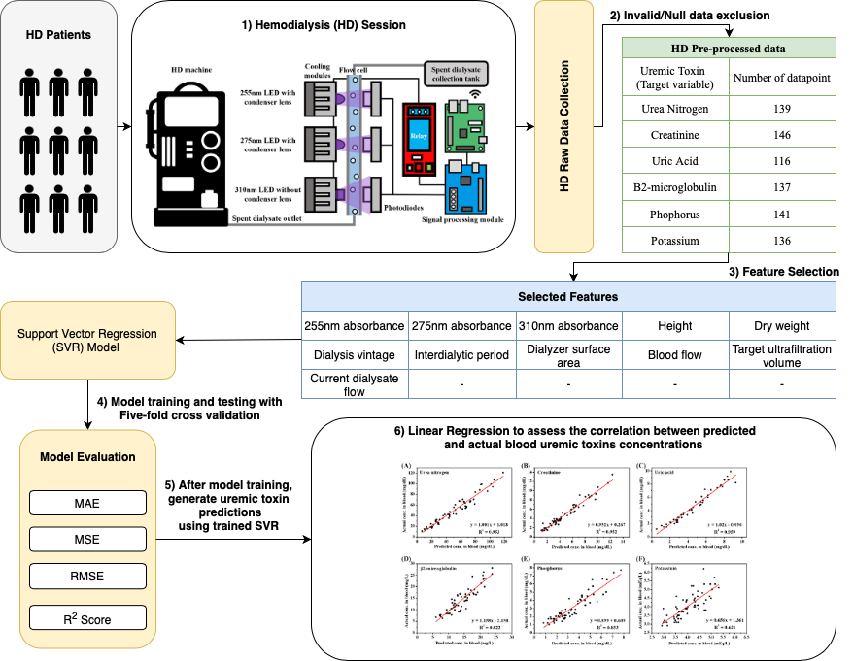
FIG. 1: Methodology Overview. The initial phase involved developing a multi-wavelength optoelectronic system for measuring the absorbance data of uremic toxins.
1) A clinical trial was conducted with 9 ESRD patients undergoing 30 HD sessions. Dialysate samples were collected at intervals, and blood samples were taken at specific time points during each HD session. The optoelectronic system measured absorbance at selected wavelengths, while data were recorded by HD machines throughout the 4-hour session. 2) Data preprocessing eliminated null and invalid entries. 3) Feature selection identified personalized features crucial for accurate uremic toxin estimation. 4) The study trained and tested the SVR model using five-fold cross-validation, employing regression evaluation metrics. 5) the uremic toxin predictions were used in 6) linear regression to assess the correlation between predicted and actual blood uremic toxin concentrations.

Wavelength Selection
During HD sessions, uremic toxin molecules are eliminated into the dialysate through the dialyzer's semi-membrane, resulting in various metabolites in the spent dialysate. Due to the multitude of molecules contributing to absorbance, the spectrum of spent dialysate exhibits overlapping phenomena [51], making it challenging to measure the concentration of a specific molecule through a single wavelength [52].
Previous studies extensively employed spectrophotometry to analyze molecules in spent dialysate, aiming to obtain absorbance at various wavelengths [53-55]. This approach facilitates the differentiation of analytes from interfering substances, enhancing measurement accuracy. Comprehensive analysis using absorbance at multiple wavelengths is essential for accurately quantifying uremic toxins in the spent dialysate. The advantage of employing multiple wavelengths lies in resolving absorption spectra complexities, leading to more reliable and accurate results [56].
Predominant UV absorbance in the spent dialysate is attributed to low molecular weights such as uric acid, prompting previous studies to preferentially use UV methods for monitoring uric acid removal [28, 57]. Choosing 255nm, 275nm, and 310nm wavelengths aims to circumvent the 280nm - 300nm range, where uric acid exhibits substantial absorption, causing complete absorption and preventing signal transmission to photodiodes. The selected wavelengths provide specificity for creatinine, uric acid, and β2-microglobulin absorption, addressing the complexities of overlapping absorption characteristics [58-60].
The rationale for selecting these wavelengths is to avoid the substantial absorption range of 280nm - 300nm [61], where uric acid causes complete absorption, hindering signal transmission through the spent dialysate. Ultimately, 255nm, 275nm, and 310nm were chosen, each contributing uniquely to the absorption of creatinine, uric acid, and β2-microglobulin. While urea's absorbance is challenging due to limited commercially available UV LED wavelengths [38], the correlation with uric acid absorbance allows estimation of urea levels during HD sessions [62-64].

Multi-wavelength Optoelectronic System
The optoelectronic system, depicted in FIG. 2, comprises key components of light sources, cooling modules, a quartz flow cell, photodiodes, a relay, and a signal processing module. The light sources consist of three UV LEDs with a radiant flux of 50 mW, a viewing angle initially at 120°, and central wavelengths of 255nm, 275nm, and 310nm, respectively (models #3939A25502D000 and #3939A27502D000 from UVT Ultraviolet Technology, Taiwan, and #CUD1AF4D from Seoul VioSYS, South Korea). Due to the significant absorption of spent dialysate below 300 nm, condenser lenses were employed to reduce the viewing angle of the 255nm and 275nm LEDs from 120° to 30°, enhancing sensitivity. This modification led to a 40-fold increase in observed values from the photodiodes, improving experimental outcomes. The lens was deemed unnecessary for the 310nm LEDs. The Grove-UV Sensor (Taiwan Smart Sensing Technology Co., Taiwan) photodiodes transform UV light photons into electrical signals, which undergo amplification and processing for measurement.
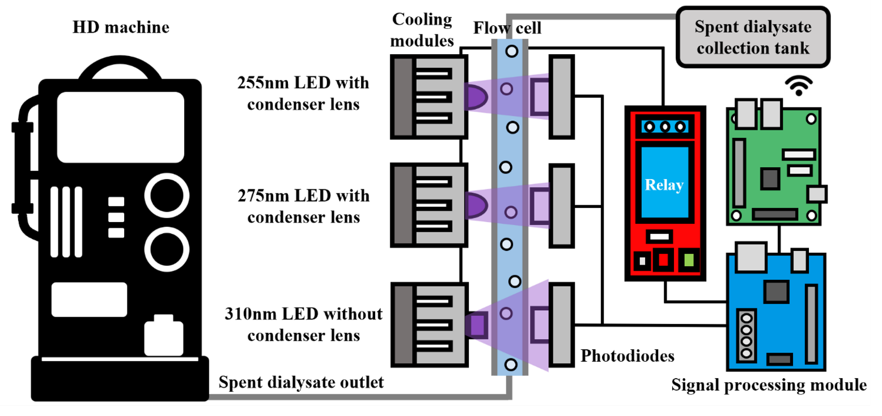
FIG. 2: Schematics of our optoelectrical system. The light source includes 255nm, 275nm and 310nm LEDs, along with cooling modules. The signal processing module commands the relay to control the UV LEDs' switch. Radiation passes through the flow cell, and photodiodes detect the resulting signal. This detected signal is transmitted to the signal processing module for storage and remote transmission.

Prolonged exposure to UV radiation can impact the accuracy and performance of the photodiodes, necessitating precautions to prevent overexposure. The LEDs are programmed to emit radiation for 500 milliseconds every minute via a relay during an HD session. To enhance precision, fifty measurements are taken at 10 millisecond intervals and then averaged into a single value, representing the measurement for a minute. Once the photodiodes receive the measured value, the signal processing modules collect the data and transmit it to the laptop for further analysis.
We utilized the cooling modules to maintain the operating temperature at 23-25°C, ensuring a stable radiant flux from the LEDs. The flow cell, a cylindrical quartz tube with a cross-sectional diameter of 9 mm² and a wall thickness of 1 mm, is connected to the outlet where spent dialysate is removed from the HD machine and the collection tank. Table 1 summarizes all specifications of our optoelectronic system.

Table 1: The specifications of the multi-wavelength optoelectronic system.
Component | Specification
Light Sources | – Three UV LEDs: 50 mW radiant flux, 120° viewing angle  – Central wavelengths: 255nm, 275nm, 310nm (Models: #3939A25502D000, #3939A27502D000, #CUD1AF4D)
Condenser Lenses | – Used for 255nm and 275nm LEDs to reduce viewing angle from 120° to 30°, enhancing light intensity
Photodiodes | – Grove-UV Sensor, Taiwan Smart Sensing Technology Co., Taiwan
Signal Processing | – Blue module commands relay, controls UV LEDs switch  – The module collects, processes data, and transmits to a laptop for further analysis
Relay | – Activates LEDs for 500 milliseconds every minute during an HD session
Exposure Control | – Radiation time programmed to prevent overexposure  –measurements taken at 10-millisecond intervals, averaged into a single value representing a minute of measurement
Cooling Modules | – Maintain operating temperature at 23-25°C to ensure stable radiant flux from LEDs
Flow Cell | – Cylindrical quartz tube: 9 mm² cross-sectional diameter, 1 mm wall thickness  – Connected to the outlet where spent dialysate is removed from the HD machine and the collection tank

Principle of Absorption Measurement
Our previous study [65] extensively detailed the application of Beer-Lambert's Law to measure absorbance in spent dialysate during HD sessions. In short:
$A=-log\left(\frac{I_{ts}}{I_{tr}}\right)=-log\left(\frac{V_{s}}{V_{r}}\right)$ (1)
where A is the absorbance, $I_{ts}$ is the intensity of the transmitted light in the sample (i.e. spent dialysate), $I_{tr}$ is the intensity of the transmitted light in the reference (i.e. fresh dialysate), $V_{s}$ is the voltage output of the photodiode on the sample, and $V_{r}$ is the voltage output of the photodiode on the reference.
The photosensitive element in the photodiodes converts the light intensity into an I signal, and then convert analog signal into a digital signal by programming. The photodiodes are operated with a 5V voltage, so the analog signal will be converted into a digital signal with a maximum of 5V. This methodology allows for the quantification of uremic toxin absorbance during HD sessions.

Data Collection and Data Pre-processing

Clinical Trial
Clinical trials were conducted at the HD Center of the National Taiwan University Hospital (NTUH) to investigate the performance of the optoelectronic system in monitoring the concentration of uremic toxins in the spent dialysate of HD patients. This study recruited 9 patients with end-stage renal disease (ESRD) who underwent conventional HD three times a week, resulting in 30 HD sessions from November 2022 to February 2023. The study was approved by the NTUH’s Research Ethics Committee (NTUH IRB No.: 202105043RINA). These patients required regular HD treatment due to various nephrological diagnoses. Participants ranged in age from 40 to 88 years, with 5 males and 4 females. Dialysis vintages ranged from 4 to 227 months, and all participants used dialyzers with high-flux polypropylene membranes (Fresenius Medical Care®). The clinical characteristics of the participants are listed in Table 2.

Table 2: Clinical characteristics of the participants.
Patient | Causes of Renal Disease | Age  (years) | Gender  (Male/Female) | Dialysis Vintage  (months) | Dialyzer  (Fresenius)
#1 | Bladder cancer | 72 | F | 93 | FX80
#2 | Polycystic kidney disease | 63 | M | 125 | FX100
#3 | Systemic Lupus Erythematosus | 40 | F | 226 | FX100
#4 | Diabetes Mellitus | 68 | F | 125 | FX80
#5 | Chinese herb related nephropathy | 82 | M | 227 | FX60
#6 | Chronic glomerulonephritis | 86 | M | 4 | FX60
#7 | Diabetes Mellitus | 74 | M | 71 | FX100
#8 | Hypertension | 88 | F | 46 | FX60
#9 | Hypertension | 57 | M | 107 | FX120

Data Collection
The spent dialysate samples were collected at the 0th, 30th, 60th, 120th, 180th, and 240th minutes, while the blood samples were collected at the 0th, 60th, and 240th minutes during each clinical experiment. The 0th minute was defined as the start, and the 240th minute was defined as the end of the HD session.
Urea nitrogen, creatinine, uric acid, phosphorus, and potassium in the collected samples were measured using ADVIA Chemistry XPT (SIMENS Healthineers, Munich, Germany). β2-microglobulin was measured using Chemiluminescence Immunoassay (CLIA) (DPC Immulite 2000 Xpi, SIMENS Healthineers®, Munich, Germany). The flow rate of spent dialysate is controlled at 0-800 mL/min by the peristaltic pumps of the HD machine (Fresenius 4008S, Fresenius Medical Care®) and approximately maintained at 500 mL/min during HD sessions. Fresenius 4008S automatically detects a pressure-tight balance every 12.5 minutes during every HD session.
The optoelectronic system is positioned at the outlet of the HD machine where the spent dialysate exits, channeling it through the system's flow cell before it proceeds to the collection tank, as shown in FIG. 3. The HD process facilitates the transfer of molecules between the fresh dialysate and the blood across a semipermeable membrane within the dialyzer. This exchange results in the transfer of uremic toxins and various electrolytes and proteins from the patient's blood into the dialysate, producing the spent dialysate. As this spent dialysate flows through the optoelectronic system, it exhibits specific absorption characteristics due to uremic toxins. The study leverages this relationship, where the absorbance measured by the system is directly related to the concentration of uremic toxins, allowing for an accurate estimation of their levels in the spent dialysate.

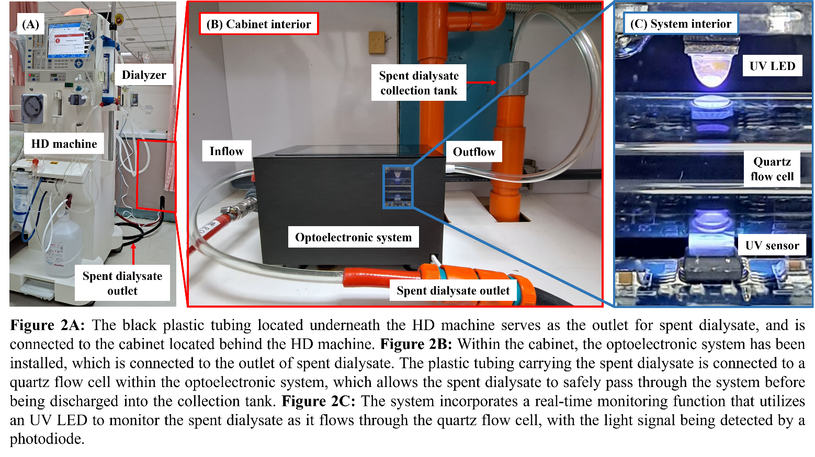
FIG. 3: (A) The plastic tubing underneath the HD machine is the outlet for spent dialysate and is connected to the cabinet behind the HD machine.
(B) The optoelectronic system has been installed within the cabinet, connecting to the outlet of the spent dialysate. The plastic tubing carrying the spent dialysate is attached to a quartz flow cell within the optoelectronic system, allowing the spent dialysate to pass through the system safely before being discharged into the collection tank.
(C) The system incorporates a real-time monitoring function utilizing a UV LED to monitor the spent dialysate as it flows through the quartz flow cell, with the light signal being detected by a photodiode.

The optoelectronic system records absorbances at 255nm, 275nm, and 310nm, with data either manually recorded by experimenters or automatically collected by HD machines (Fresenius 4008S, Fresenius Medical Care®) throughout each 4-hour HD session. Data are obtained at 1-minute intervals, resulting in 240 data points for each feature in every session.

Data Pre-processing
After collecting the data, we quantitatively analyzed uremic toxin concentrations, and the detailed results are presented in Table 3. Afterward, we conducted exclusion procedures to address invalid or null values, removing a portion of the dataset containing anomalies, such as abrupt fluctuations from drug administration during sessions and instances involving toxins. Following the exclusion process, the number of final data points for each target variable is displayed in Table 4.
Table 3: Concentrations of uremic toxins in the spent dialysate and patients’ serum.
 | Uremic toxin, unit | Range | Mean ± SD
Spent dialysate | Urea nitrogen, mg/dL | 4.0 - 61.9 | 19.1 ± 11.3
 | Creatinine, mg/dL | 0.11 - 4.1 | 1.21 ± 0.78
 | Uric acid, mg/dL | 0.5 - 3.3 | 1.27 ± 0.65
 | β2-microglobulin, mg/L | 0.04 - 3.87 | 1.26 ± 0.85
 | Phosphorus, mg/dL | 0.3 - 1.8 | 0.74 ± 0.35
 | Potassium, mEq/L | 2.1 - 5.6 | 2.68 ± 0.44
Serum | Urea nitrogen, mg/dL | 7.1 - 120.6 | 53.8 ± 36.5
 | Creatinine, mg/dL | 1.39 - 13.5 | 5.06 ± 2.78
 | Uric acid, mg/dL | 0.5 - 9.9 | 4.27 ± 2.89
 | β2-microglobulin, mg/L | 6.26 - 28.08 | 17.4 ± 7.81
 | Phosphorus, mg/dL | 1.0 - 7.7 | 3.06 ± 1.64
 | Potassium, mEq/L | 2.8 - 6.2 | 4.12 ± 0.80

Table 4: Number of data points for each target variables.
Target Variable | Number of data points
Urea Nitrogen | 139
Creatinine | 146
Uric Acid | 116
β2-microglobulin | 137
Phosphorus | 141
Potassium | 136

Feature Selection
We performed feature selection to identify personalized features crucial for accurate uremic toxin estimation while mitigating the risk of overfitting through dimensionality reduction [78-81]. Our approach involves an exhaustive enumeration of potential features, encompassing patient-specific characteristics such as gender, age, height, weight, blood pressure, ethnic background, dialysis vintage, and interdialytic period. Additionally, we consider a comprehensive set of HD parameters, ranging from membrane area and ultrafiltration coefficient to machine-generated readings like dialysate sodium concentration, ultrafiltration targets, dialysate flow rate, venous pressure, blood flow, and transmembrane pressure. The complete feature list is detailed in Table 5.

Table 5: The complete set of the features analyzed in the study with corresponding numerical ranges.
 | Feature (unit) | Mean ± SD | Range
Optoelectronic system | 255nm absorbance (a.u.) | 0.816 ± 0.43 | 0.195 - 1.919
 | 275nm absorbance (a.u.) | 0.765 ± 0.38 | 0.102 - 1.631
 | 310nm absorbance (a.u.) | 0.159 ± 0.08 | 0.003 - 0.371
Patient characteristic | Gender | - | -
 | Age (years) | 67.68 ± 14.784 | 40 - 88
 | Height (m) | 1.62 ± 0.11 | 1.48 – 1.76
 | Dry weight (kg) | 57.2 ± 12.4 | 38.4 – 79.5
 | Dialysis vintage (years) | 9.55 ± 6.65 | 0.33 – 18.92
 | Interdialytic period (d–y) | 2.47 ± 0.51 | 2 - 3
HD machine parameter | Dialyzer surface area (m²) | 1.975 ± 0.479 | 1.4 - 2.5
 | MWCO (Daltons) | 88652.48 ± 20185 | 60000 - 120000
 | Hourly dehydration volume (mL/h) | 466.687 ± 189.364 | 29 – 950
 | Current dehydration volume (mL) | 885.751 ± 767.029 | 13 – 3685
 | Dialysis ion concentration (mmol/L) | 137.124 ± 1.68 | 135 – 140
 | Venous pressure (mmHg) | 166.97 ± 57.82 | 133 – 273
 | Ultrafiltration coefficient | 59.943 ± 15.884 | 38 – 87
 | Systolic pressure (mmHg) | 155 ± 23.904 | 111 – 176
 | Transmembrane pressure (mm–g) | 66.53 ± 23.33 | 7 - 105
 | Blood flow (mL/min) | 252.15 ± 34.31 | 198 - 351
 | Target ultrafiltration volume (mL) | 1858.9 ± 694.1 | 600 - 3800
 | Current dialysate flow (mL/min) | 536.16 ± 85.79 | 467 - 799
Other | Dialysis time (min) |  | 0 - 240

To ascertain the significance of each feature, we conduct the ANOVA (Analysis of Variance) F-test to evaluate the importance of the features on the target variables. Moreover, we employ a wrapper approach [66] to evaluate various feature subsets using the SVR model to pinpoint the most accurate and computationally efficient set for predicting toxin levels in HD patients. Our feature selection analysis identifies key attributes critical for accurately gauging uremic toxin levels in the spent dialysate. The key attributes encompass a range of patient-specific data such as height, dry weight, dialysis history, time between treatments, and the membrane area of the dialyzer used. Real-time HD machine metrics like blood flow, ultrafiltration targets, and dialysate flow rate are also integral. The final selected features are presented in Table 6.

Table 6: Selected features analyzed in the study with corresponding numerical ranges.
 | Feature (unit) | Mean ± SD | Range
Optoelectronic system | 255nm absorbance (a.u.) | 0.816 ± 0.43 | 0.195 - 1.919
 | 275nm absorbance (a.u.) | 0.765 ± 0.38 | 0.102 - 1.631
 | 310nm absorbance (a.u.) | 0.159 ± 0.08 | 0.003 - 0.371
Patient characteristic | Height (m) | 1.62 ± 0.11 | 1.48 – 1.76
 | Dry weight (kg) | 57.2 ± 12.4 | 38.4 – 79.5
 | Dialysis vintage (years) | 9.55 ± 6.65 | 0.33 – 18.92
 | Interdialytic period (d–y) | 2.47 ± 0.51 | 2 - 3
 | Dialyzer surface area (m²) | 1.975 ± 0.479 | 1.4 - 2.5
HD machine parameter | Blood flow (mL/min) | 252.15 ± 34.31 | 198 - 351
 | Target ultrafiltration volume (mL) | 1858.9 ± 694.1 | 600 - 3800
 | Current dialysate flow (mL/min) | 536.16 ± 85.79 | 467 - 799

Support Vector Regression Model
The Support Vector Regression (SVR) model is adapted as the primary machine-learning model for predicting toxin levels in HD. SVR has demonstrated success in a few related applications within the context of HD. A study utilized the Support Vector Machine (SVM) alongside logistic regression to predict and manage HD adequacy, complications, and vascular access performance [83]. Similarly, another study incorporated SVM as one of four classifiers to develop a predictive model for identifying predictors of death in HD patients [84]. Researchers in [85] employed the Multiple Kernel SVR based on the Maximizes the Average Similarity (MKSVRMAS) model to predict the dry weight of HD patients.
While these studies show the versatility of SVM in HD applications, the specific application of SVR for predicting toxin levels in HD has yet to be explored in the existing literature. Therefore, our study aims to fill this knowledge gap by employing SVR to enhance the accuracy of toxin level predictions during HD. Formally, we formulate the SVR in our study as follows:
Minimize $\frac{1}{2} {\left\|ω\right\|}^{2}+C\sum_{i=1}^{n}{(ξ_{i}+ξ_{i}^{*})}$ (2)
Subject to $\left\{\begin{aligned}y_{i}-ω^{T}ϕ\left(x_{i}\right)-b≤ε+ξ_{i} \\ ω^{T}ϕ\left(x_{i}\right)+b-y_{i}≤ε+ξ_{i}^{*} \\ ξ_{i}, ξ_{i}^{*}≥0\end{aligned}\right.$ (3)
where $ω$ is the weight vector, $b$ is the bias term, $ϕ()$ signifies the feature mapping function, $x_{i}$ and $y_{i}$ are the input and output samples, respectively, and $ε$ is the margin of tolerance for errors. The variables $ξ_{i}$ and $ξ_{i}^{*}$ are non-negative slack variables that allow for deviations from the hyperplane. The constant $C$ serves to determine the trade-off between achieving a wide margin and minimizing errors.
By solving this optimization problem, SVR identifies a hyperplane that maximizes the margin while allowing for a certain level of error or tolerance in prediction. What sets SVR apart from conventional regression methods is its ability to handle non-linear relationships between input variables and the output variable. It achieves this by employing the feature mapping function ϕ (), which transforms the data into a higher-dimensional space. In this space, non-linear relationships can be more effectively captured.

Experimental Details
In this study, we primarily focus on predicting toxin levels in HD patients, addressing it as a multivariate regression task denoted by D_{t}. We formally define the problem as a multivariate regression task denoted by D_{t}, a dataset comprising N data points, where each data point $X_{i}=(x_{i,1}, x_{i,2},…,x_{i,m},)$ consists of m features. The target variables include 1) urea nitrogen (UN), 2) creatinine (C), 3) uric acid (UA), 4) β2-microglobulin (β2), 5) phosphorus (Ph), and 6) potassium (K), denoted as $Y_{i}=({UN}_{i}, C_{i},{UA}_{i},{β2}_{i},{Ph}_{i},K_{i},)$. We aim to develop a robust model capable of accurately predicting these toxin levels.
Post-collection, we pre-processed the data by eliminating invalid values using Microsoft Excel. Further, the ANOVA F-test and the wrapper approach using the SVR were conducted to identify important features. Following the feature selection, we executed experiments utilizing three sets of features (m = 8, m = 3, and m = 11), where the first set only contains personalized features, the second set only contains absorbance features, and the third set contains both absorbance and personalized features. We aim to investigate the importance of absorbance features and the effectiveness of incorporating personalized features in predicting toxin levels in HD.
The SVR model is employed using the Regression Learner tool in MATLAB (2022b) with a second-order polynomial kernel function. Table 7 lists the model's hyperparameters. the features are normalized to have a mean of 0 and a standard deviation of 1. This normalization ensures equal contributions from all features during model training, preventing those with larger scales from dominating the learning process and maintaining sensitivity to the scale of input features.

Table 7: The hyperparameters of the SVR model.
Hyperparameter | Value
Kernel function | polynomial
Polynomial order | 2
Kernel Scale | auto
Standardize | True

For the model training, we employed a five-fold cross-validation, where the model was trained on k − 1 folds and tested on the kth fold. This approach enhances the model's robustness and guards against overfitting. The performance of the model for each fold was evaluated using key regression metrics: 1) Mean Absolute Error (MAE), 2) Mean Squared Error (MSE), 3) Root Mean Squared Error (RMSE), and 4) R-square coefficient score (R²). These metrics were selected for their effectiveness in assessing predictive accuracy and overall model performance in predicting toxin levels in HD. The calculation of these metrics involves:
$MAE=\frac{1}{n}\sum_{j=1}^{n}{\left|y_{j}-\hat{y_{j}}\right|}$ (4) $MSE=\frac{1}{n}\sum_{j=1}^{n}{{\left(y_{j}-\hat{y_{j}}\right)}^{2}}$ (5)
$RMSE=\sqrt{\frac{1}{n}\sum_{j=1}^{n}{{\left(y_{j}-\hat{y_{j}}\right)}^{2}}}$ (6)
$R^{2}=1-\frac{\sum_{j=0}^{n}{{\left(y_{j}-\hat{y_{j}}\right)}^{2}}}{\sum_{j=0}^{n}{{\left(y_{j}-\overline{y}\right)}^{2}}}$ (7)
where n is the number of observations, $y_{j}$ is the actual value, $\hat{y_{j}}$ is the predicted value, $\overline{y}$ is the mean of the observed data.

Serum Concentration Conversion
This study also aims to examine the correlation between predicted and actual concentrations in the blood. Therefore, linear regression is employed to convert predictions from the trained SVR into blood concentration equivalents, enabling the determination of the actual concentration of uremic toxins in the blood. The linear regression analysis involves comparing the actual concentrations of uremic toxins in the spent dialysate with those in the blood, facilitating the acquisition of the corresponding concentration conversion. Consequently, the predicted uremic toxin concentrations in the blood can be computed based on their counterparts in the spent dialysate.

Results
This section presents the results of the absorption spectrum obtained by the optoelectronic system in spent dialysate during HD, emphasizing its suitability for real-time analysis. Following this, we use the SVR model to showcase the importance of absorbance features, coupled with selected personalized features, in predicting toxin levels during HD. To provide a comprehensive perspective, we visually represent the predicted toxin concentrations obtained from our trained SVR model, underscoring its robustness with an additional 11 sample data collected during the final clinical experiment. Finally, we delve into the conversion results, elucidating the predicted uremic toxin concentrations from spent dialysate to blood, thereby adding depth to our findings.

Measurement Results of Optoelectronic System in Spent Dialysate during HD
The absorbance fluctuations in spent dialysate during HD sessions are measured using our optoelectronic system and shown in FIG. 4 with established spectrophotometric data for real-time analysis. The cost-effectiveness and operational simplicity of the system advocate its suitability for clinical applications, characterized by consistent 12.5-minute oscillations that indicate reliable monitoring throughout treatment sessions.
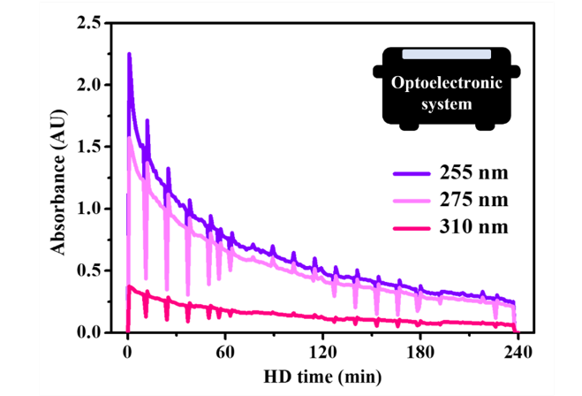
FIG. 4: The absorption variations of the spent dialysate, measured by the optoelectronic system at 255nm, 275nm and 310nm, during a 4-hour HD session. The graph demonstrates the ability of the optoelectronic system to capture absorbance fluctuations in spent dialysate during HD, aligning with established spectrophotometric data and affirming its viability for real-time analysis.

SVR Results with Different Sets of Features
Three scenario were explored and trained by SVRwith (i) data comprising solely personalized features (m = 8), (ii) data consisting only of absorbance features (m = 3), and (iii) a combination of both absorbance data and personalized features (m = 11) to predict uremic toxin concentrations in the spent dialysate. The goal was to assess the significance of absorbance data and evaluate the effectiveness of incorporating personalized features in enhancing estimation accuracy. Table 8 shows the results of five-fold cross-validation regression with different feature sets for each uremic toxin in the spent dialysate.

Table 8: The five-fold cross validation results using SVR with (i) personalized features only,
(ii) absorbance features only, and (ii) absorbance with personalized features for individual uremic toxins. The bolded values represent the best value across different metrics.
 | Uremic toxin | MAE | MSE | RMSE | R²
Personalized features  only | Urea nitrogen | 15.974 | 1678.3 | 40.967 | -16.91
 | Creatinine | 1678.3 | 1.89 | 1.374 | -2.3
 | Uric acid | 40.967 | 0.546 | 0.73 | -0.48
 | β2-microglobulin | -16.91 | 0.772 | 0.878 | -1.08
 | Phosphorus | 0.775 | 0.105 | 0.324 | -2.29
 | Potassium | 1.89 | 1.05 | 1.024 | -8.58
Absorbance  only | Urea nitrogen | 3.452 | 22.076 | 4.699 | 0.763
 | Creatinine | 0.285 | 0.159 | 0.398 | 0.727
 | Uric acid | 0.152 | 0.038 | 0.194 | 0.898
 | β2-microglobulin | 0.251 | 0.126 | 0.354 | 0.666
 | Phosphorus | 0.167 | 0.061 | 0.247 | 0.438
 | Potassium | 0.093 | 0.014 | 0.118 | 0.553
Absorbance with  personalized  features | Urea nitrogen | 1.168 | 2.448 | 1.565 | 0.974
 | Creatinine | 0.100 | 0.025 | 0.157 | 0.957
 | Uric acid | 0.080 | 0.011 | 0.106 | 0.970
 | β2-microglobulin | 0.174 | 0.054 | 0.233 | 0.853
 | Phosphorus | 0.085 | 0.012 | 0.111 | 0.885
 | Potassium | 0.075 | 0.010 | 0.099 | 0.684
Mean Absolute Error (MAE), Mean Square Error MSE), Root Mean Square Error (RMSE), Coefficient of determination (R²)

Accurate measurement of uremic toxins is essential for assessing renal function. Table 8 reveals that when the SVR model is trained solely on personalized features (m = 8), it exhibits suboptimal performance across various uremic toxins. Urea nitrogen shows relatively high MAE and MSE, with a negative R², indicating limited predictive power. Although creatinine displays improved performance with lower MAE and MSE, the negative R² implies a lack of correlation. Similarly, uric acid, β2-microglobulin, phosphorus, and potassium exhibit mixed results, suggesting that HD personalized features alone are ineffective in predicting uremic toxins.
In contrast, training the SVR model solely on absorbance features (m = 3) results in slightly lower MAE and MSE values, and positive R² values indicate a better fit. However, the absolute values of R² are relatively low for some toxins, indicating room for improvement. Absorbance effectiveness varies among different toxins, with uric acid showing a strong correlation (R² value of 0.898), while phosphorus and potassium exhibit modest correlations (R² values of 0.438 and 0.553). This finding suggests that absorbance measurements may serve as reliable indicators for some toxins but not uniformly for all.
Enhancing the analysis by incorporating individual characteristics improves the accuracy of uremic toxin level predictions. The combined model using both absorbance and personalized features (m = 11) yields the best overall results, refining the precision of the models. For instance, integrating personal data enhances predictions for creatinine, with the R² value increasing from 0.727 to 0.957. The phosphorus level also benefits from including personal features, nearly doubling its R² value, emphasizing the complementary nature of absorbance and personalized features in enhancing predictive performance.

Results of Predicted Concentration Variation
To make a more comprehensive comparison between the predicted concentrations of uremic toxins and their corresponding actual concentrations in the spent dialysate, we expanded the dataset to include 11 additional samples during the final clinical experiment. This meticulous approach to data collection resulted in a refined depiction of concentration trends, enhancing the accuracy and clarity of our analysis. In this experimental session, FIG. 5 represents the alignment between the predicted concentration curve derived from the best trained SVR model and the actual concentration response in the spent dialysate. The curves illustrate that the trained SVR model can accurately predict uremic toxins.
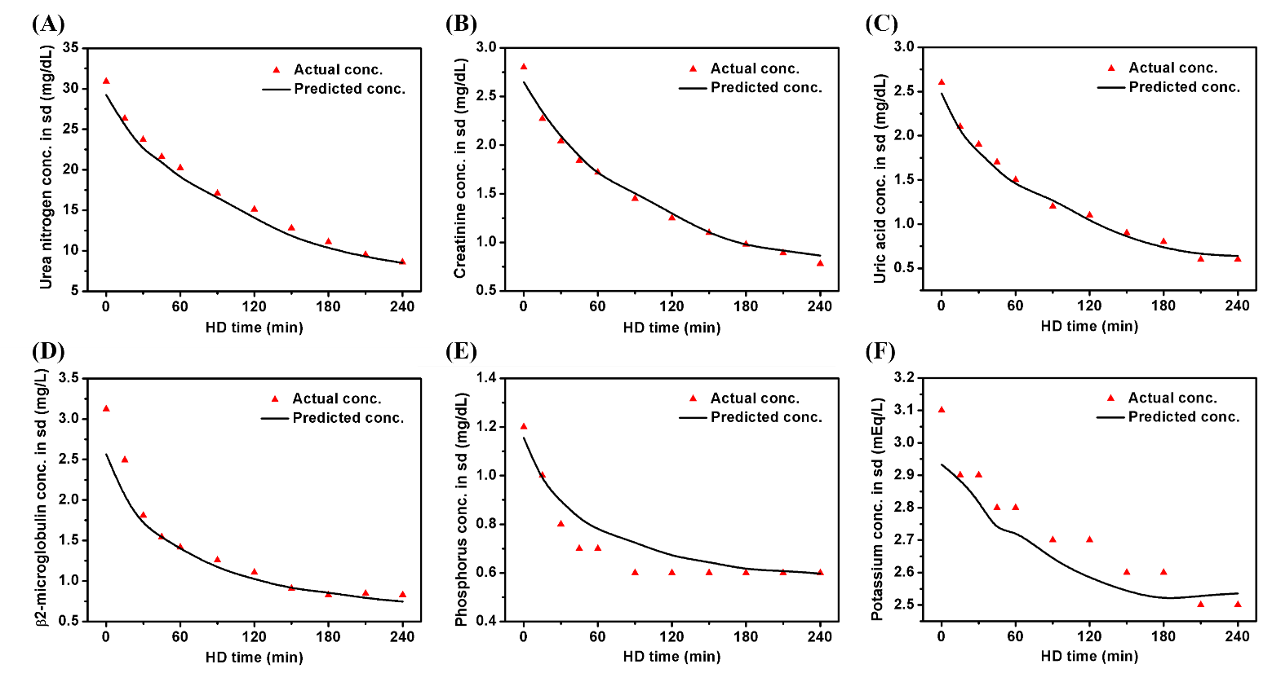
FIG. 5: Comparison between the predicted concentration curve generated by the best trained SVR model and the actual concentration response in the spent dialysate during the final clinical experiment. The curves demonstrate the high accuracy of the trained SVR model in predicting uremic toxins.

Results of Conversion of Predicted Uremic Toxin Concentrations from Spent Dialysate to Blood
Linear regression is subsequently applied to convert these predictions into blood concentration equivalents. FIG. 6 compares the predicted blood concentrations with the actual measurements. Impressive correlation coefficients are observed for urea nitrogen, creatinine, and uric acid, with R-squared values of 0.953, 0.952, and 0.959, respectively, highlighting the model's robust predictive accuracy. β2-microglobulin and phosphorus also exhibit a strong predictive relationship, with R-squared values of 0.822 and 0.853. Despite a lower R-squared value of 0.621, potassium still demonstrates a reasonable level of predictability. These findings underscore the potential of linear regression in dialysis-related diagnostics, particularly emphasizing its effectiveness in predicting urea nitrogen, creatinine, and uric acid levels from dialysate analysis.
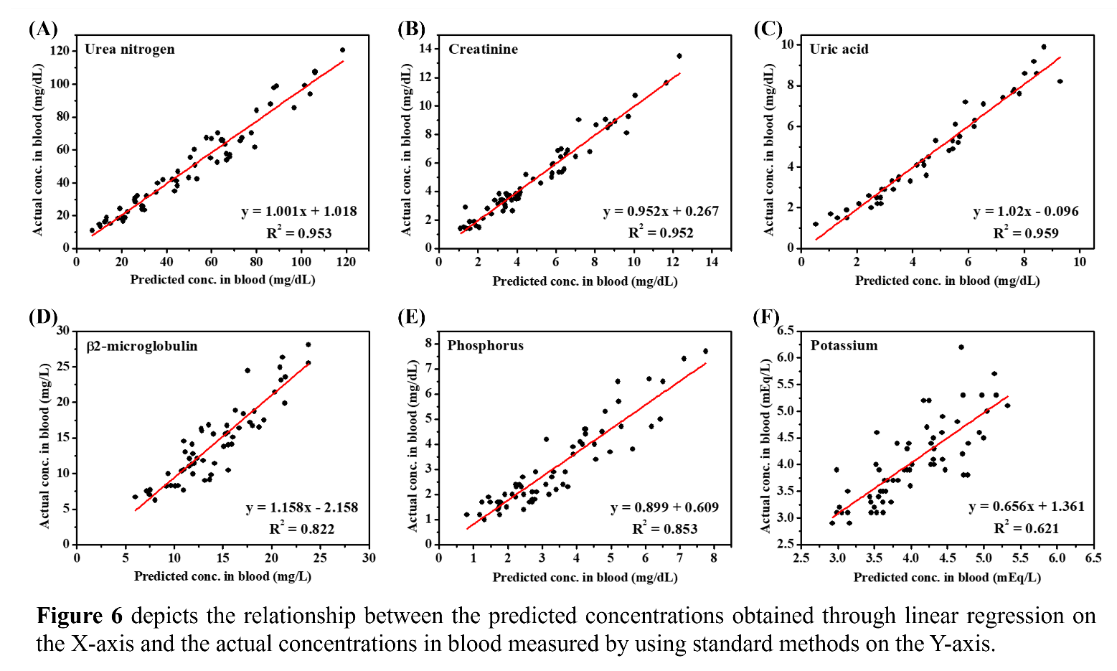
FIG. 6: The relationship between the predicted concentrations and the actual concentrations in blood (e.g. by using linear regression prediction vs by using standard analytic methods). The analysis underscores the robust predictive accuracy of the SVR model, emphasizing its effectiveness in predicting uremic toxins from dialysate analysis.

Discussion

Optoelectronic System
This study aims to address the limitations of traditional HD treatment by proposing a novel method that integrates multi-wavelength optoelectronic sensing technology and ML for real-time monitoring. We developed a multi-wavelength optoelectronic system to measure the absorption spectrum of the spent dialysate, which exhibits significant variations in absorbance throughout the HD sessions. The consistency of these variations with previous studies using a spectrophotometer confirms the potential of the optoelectronic system for online monitoring [67]. Moreover, the practical advantages of its lower cost and simplicity make it a favorable choice for online monitoring of HD treatments. This system holds the promise to eliminate the necessity for blood collection, as it allows for the direct utilization of absorbance features to measure uremic toxins in the blood, marking a significant advancement in the efficiency and non-invasive nature of HD monitoring.

Feature Importance Evaluation

Absorbance Features
The significance of absorbance features in predicting uremic toxin levels during HD cannot be overstated, as demonstrated in our SVR model analysis. While personalized features contribute, our study reveals their insufficiency to replace the critical role played by absorbance features. Exclusively training the SVR model with personalized features results in inaccurate predictions, whereas relying solely on absorbance features yields precise estimations. Personalized features enhance but are secondary, with absorbance features serving as the primary drivers for accurate predictions.
FIG. 7 displays the RMSE of five-fold cross-validation for SVR models trained with (i) selected personalized features, (ii) absorbance features only, and (iii) a combination of absorbance with personalized features. Consistently, SVR trained with absorbance and personalized features demonstrates the lowest errors across all uremic toxin predictions, followed by SVR trained with absorbance features alone. SVR trained with selected personalized features exhibits the highest errors.
FIG. 7: Visualization of RMSE scores for uremic toxins based on SVR models with (i) personalized features only, (ii) absorbance only, and (iii) both absorbance and personalized features. SVR trained with absorbance and personalized features exhibits the lowest RMSE across all uremic toxin predictions, followed by SVR trained with absorbance features only. Conversely, SVR trained with selected personalized features displays the highest errors.

Our findings underscore that personalized features alone cannot achieve satisfactory predictive performance, highlighting the critical role of absorbance features. This distinction is crucial, emphasizing that absorbance readings form the foundation of our predictive model. This straightforward approach, where absorbance features take precedence, is validated by the improved metrics across our models. Combining broad absorbance data with individual health details yields more comprehensive and accurate estimations of uremic toxin levels. Therefore, our study advocates for the irreplaceable role of absorbance features, asserting that personalized features can only complement and enhance but cannot substitute for the pivotal absorbance data in predicting uremic toxins during HD. Moreover, the results highlight our system's potential to complement or even substitute conventional blood testing, offering continuous feedback on HD adequacy and preemptively signaling potential adverse events.

Personalized Features
The personalized feature selection process initially considered 22 features, detailed in Table 5. To mitigate the potential negative impact of an excessive number of features on SVR model performance, we conducted feature selection, excluding certain features based on their lower importance and redundancies. For instance, despite existing studies suggesting the influence of age and gender on uremic toxin levels, our analysis revealed minimal effects on the model [54, 87, 88]. Dialysis time was omitted due to its predictable linear relationship with absorbance changes, and the relevance of venous pressure to toxin accumulation and removal was deemed minimal [89].
Likewise, we observed a direct correlation between Transmembrane Pressure (TMP) and ultrafiltration volume, leading to removing these parameters to avoid model overfitting. These parameters were excluded, considering the shared dialysate sodium concentration among most patients and the interconnection of ultrafiltration coefficient and Molecular Weight Cut-Off (MWCO) to dialyzer size. FIG. 8 displays the RMSE of five-fold cross-validation for SVR models trained with i) all 22 personalized and absorbance features ii) and the 11 selected personalized and absorbance features. The SVR model trained with the selected features exhibited better overall performance, justifying our implementation of feature selection.
FIG. 8: The RMSE scores for uremic toxins in our study, comparing models trained with all 22 personalized and absorbance features to those trained with the selected 11 personalized and absorbance features. Notably, the SVR model trained with the selected features outperformed the model trained with all features based on the lower RMSE scores across all uremic toxin levels predictions.

Considering their significance and interrelations, this meticulous feature pruning resulted in a streamlined and efficient model for predicting uremic toxin levels during HD. The selected features were further evaluated using the F-Test algorithm, examining each feature's statistical impact on the target variables. The cumulative importance scores from the ANOVA F-test, presented in FIG. 9, highlight the substantial contribution of absorbance values derived from the optoelectronic system, particularly at 310nm, 275nm, and 255nm. These results underscore the pivotal role of these specific absorbance metrics in enhancing the precision and accuracy of the SVR model in estimating uremic toxin concentrations.
FIG. 9: The cumulative importance scores for uremic toxins derived from the ANOVA F-test.

The personalized features were also assessed for their importance scores. For example, dialysis vintage exhibited the highest importance score among the personalized features, potentially indicating a correlation between longer dialysis vintage and the accumulation of small molecular uremic toxins [56]. The second and third highest are the dry weight and height, reflecting the reported correlation between greater body mass and creatinine concentration [54].

Online Monitor of HD Adequacy
In a recent study utilizing the Adimea® machine, UV spectroscopy analysis of spent dialysate enabled the monitoring of single pool Kt/V in HD patients [68]. While this research emphasized the potential enhancement of dialysis adequacy, it primarily concentrated on single-pool Kt/V measurements. In contrast, our research takes a divergent approach by employing a multi-wavelength optoelectronic system to evaluate a broader spectrum of uremic toxins, including β2-microglobulin. This method allows for a more comprehensive assessment of HD treatment, encompassing not only single pool Kt/V but also critical markers such as creatinine and β2-microglobulin. Consequently, our study provides a more in-depth insight into dialysis efficacy and the clearance of diverse toxins.

Scope and Limitations of the Study
Our study is centered on developing and implementing a cost-effective and straightforward multi-wavelength optoelectronic system integrated with ML for real-time monitoring of uremic toxin levels during HD sessions. The primary focus lies in analyzing absorbance features at 310nm, 275nm, and 255nm to capture target uremic toxins effectively. Additionally, we explore the impact of personalized features on enhancing the accuracy of uremic toxin predictions.
Our analysis employs linear regression to determine the actual concentrations of uremic toxins in the blood, specifically conducting a conversion between the concentrations in spent dialysate and those in the blood using linear regression analysis. It is essential to note that our study is limited to six uremic toxins as target variables, and the cohort considered comprises HD patients from the HD Center of National Taiwan University Hospital, which may limit the generalizability of our optoelectronic system's performance to a broader population.
Despite meticulous efforts, certain limitations should be acknowledged. The manual data collection introduces the potential for human error, and the study may not provide insights into the long-term performance and sustainability of the optoelectronic system in diverse clinical scenarios. We define the problem as a multivariate regression rather than a time-series multivariate regression problem. Our pre-processing techniques are confined to feature selection and data standardization, with no consideration for data imputation.

Conclusion
This study introduces a novel method using a cost-effective multi-wavelength optoelectronic system, incorporating personalized features and ML for online monitoring during HD treatment. The focus on absorbance features at 310nm, 275nm, and 255nm enhances the system's effectiveness in capturing uremic toxins. Utilizing both absorbance and personalized features in SVR model proves superior, emphasizing the foundational role of absorbance data. Linear regression analysis establishes strong correlations for various uremic toxins, facilitating translation into blood concentration equivalents. This real-time monitoring method has the potential to substitute traditional and time-consuming blood testing, contributing to the practical implementation of precision medicine in HD treatment. The outcomes of this study hold potential implications for improving patient outcomes and optimizing healthcare delivery in nephrology.
Our future work needs to assess the practical benefits of our approach. In addition to implementing the future works outlined in Section 2.4, further research should involve comparative studies to assess treatment outcomes between our system and conventional HD methods. This evaluation should focus on treatment adequacy, symptom management, and overall patient satisfaction. The limited sample size of nine patients over 30 sessions in our study underscores the need for further investigation with larger patient groups to strengthen the validity of our findings and explore broader clinical outcomes, particularly the impact of our method on patient well-being.

Disclosures
The authors declare that they have no known competing financial interests or personal relationships that could have appeared to influence the work reported in this paper. Yen-Wen Lu reports research financial support was provided by National Taiwan University, National Science and Technology Council, Taiwan (NSTC 111-2218-E-002-042). Yen-Wen Lu reports administrative support was provided by National Taiwan University Hospital. During the preparation of this work the author(s) used ChatGPT in order to improve the language. After using this tool/service, the author(s) reviewed and edited the content as needed and take(s) full responsibility for the content of the publication.

Acknowledgements
The authors thank all registered professional nurses and participants of the clinical experiment at the HD center of National Taiwan University Hospital for their assistance in this study, the support in assay from Union Clinical Laboratory, Taipei, Taiwan, and the UV LED provided by Ultraviolet Technology Corporation, Taiwan. The authors also thank Mr. Ting-Yu Wan for manuscript editing. This study is approved by the Research Ethics Committee of National Taiwan University Hospital (NTUH IRB No.: 202105043RINA) for studies involving humans.

References
1. Ashley, E.A., The precision medicine initiative: a new national effort. Jama, 2015. 313(21): p. 2119-2120.
2. Collins, F.S. and H. Varmus, A new initiative on precision medicine. New England journal of medicine, 2015. 372(9): p. 793-795.
3. Ashley, E.A., Towards precision medicine. Nature Reviews Genetics, 2016. 17(9): p. 507-522.
4. Mesko, B., The role of artificial intelligence in precision medicine. 2017, Taylor & Francis. p. 239-241.
5. Kosorok, M.R. and E.B. Laber, Precision medicine. Annual review of statistics and its application, 2019. 6: p. 263-286.
6. Zhang, K. and W. Ling, Health Monitoring of Human Multiple Physiological Parameters Based on Wireless Remote Medical System. IEEE Access, 2020. 8: p. 71146-71159.
7. Zhybak, M., et al., Creatinine and urea biosensors based on a novel ammonium ion-selective copper-polyaniline nano-composite. Biosensors and Bioelectronics, 2016. 77: p. 505-511.
8. Cánovas, R., M. Cuartero, and G.A. Crespo, Modern creatinine (Bio)sensing: Challenges of point-of-care platforms. Biosensors and Bioelectronics, 2019. 130: p. 110-124.
9. Ciou, D.S., et al., Colorimetric and amperometric detection of urine creatinine based on the ABTS radical cation modified electrode. Sensors and Actuators, B: Chemical, 2020. 314.
10. Rakesh Kumar, R.K., et al., Zwitterion-Functionalized Cuprous Oxide Nanoparticles for Highly Specific and Enzymeless Electrochemical Creatinine Biosensing in Human Serum. ACS Applied Nano Materials, 2023. 6(3): p. 2083-2094.
11. Liu, Y., et al., A biosensing array for multiplex clinical evaluation of glucose, creatinine, and uric acid. Biosensors and Bioelectronics, 2023. 241: p. 115699.
12. Johnson, K.B., et al., Precision medicine, AI, and the future of personalized health care. Clinical and translational science, 2021. 14(1): p. 86-93.
13. Arya, S.S., et al., The convergence of traditional and digital biomarkers through AI-assisted biosensing: A new era in translational diagnostics? Biosensors and Bioelectronics, 2023. 235: p. 115387.
14. Fend, R., et al., Monitoring haemodialysis using electronic nose and chemometrics. Biosensors and Bioelectronics, 2004. 19(12): p. 1581-1590.
15. Pundir, C.S., S. Jakhar, and V. Narwal, Determination of urea with special emphasis on biosensors: A review. Biosensors and Bioelectronics, 2019. 123: p. 36-50.
16. Thavarungkul, P., et al., Continuous monitoring of urea in blood during dialysis. Biosensors and Bioelectronics, 1991. 6(2): p. 101-107.
17. Petitclerc, T., et al., A model for non-invasive estimation of in vivo dialyzer performances and patient's conductivity during hemodialysis. The International journal of artificial organs, 1993. 16(8): p. 585-591.
18. Polaschegg, H.-D., On-line dialyser clearance using conductivity. Pediatric Nephrology, 1995. 9(Suppl 1): p. S9-S11.
19. Moret, K.E., C.H. Beerenhout, and J.P. Kooman, Variations in predialytic plasma conductivity in dialysis patients: effect on ionic mass balance and blood pressure. Asaio Journal, 2011. 57(1): p. 53-61.
20. Edalat-nejad, M., et al., Online Conductivity Monitoring, despite underestimating hemodialysis adequacy: Still a reliable practical tool. Arak Medical University Journal, 2013. 15: p. 77-84.
21. Sant, W., et al., Development of chemical field effect transistors for the detection of urea. Sensors and Actuators B: Chemical, 2003. 95(1-3): p. 309-314.
22. Sant, W., et al., On-line monitoring of urea using enzymatic field effect transistors. Sensors and Actuators B: Chemical, 2011. 160(1): p. 59-64.
23. Geletu, A.K. and T.R. Soreta, Electrochemical Fabrication of Randomly Nanoarrayed Electrodes to Enhance Sensitivity and Selectivity of Sensors. International Journal of Sciences: Basic and Applied Research, 2017. 32: p. 117-131.
24. Hanssen, B.L., S. Siraj, and D.K. Wong, Recent strategies to minimise fouling in electrochemical detection systems. Reviews in Analytical Chemistry, 2016. 35(1): p. 1-28.
25. Kurita, R., N. Yabumoto, and O. Niwa, Miniaturized one-chip electrochemical sensing device integrated with a dialysis membrane and double thin-layer flow channels for measuring blood samples. Biosensors and Bioelectronics, 2006. 21(8): p. 1649-1653.
26. Michalec, M., et al., Optoelectronic detectors and flow analysis systems for determination of dialysate urea nitrogen. Sensors and Actuators B: Chemical, 2016. 226: p. 563-569.
27. Fridolin, I., M. Magnusson, and L.-G. Lindberg. Measurement of solutes in dialysate using UV absorption. in Optical Diagnostics and Sensing of Biological Fluids and Glucose and Cholesterol Monitoring. 2001. SPIE.
28. Jerotskaja, J., et al. Concentration of uric acid removed during dialysis. Estimated by multi wavelength and processed ultra violet absorbance spectra. in 2010 Annual International Conference of the IEEE Engineering in Medicine and Biology. 2010. IEEE.
29. Tomson, R., et al. Development of the model for the optical multiwavelength monitoring of creatinine in the spent dialysate. in 2010 12th Biennial Baltic Electronics Conference. 2010. IEEE.
30. Collins, A.J., et al., Urea index and other predictors of hemodialysis patient survival. American journal of kidney diseases, 1994. 23(2): p. 272-282.
31. Lowrie, E.G., W.H. Huang, and N.L. Lew, Death risk predictors among peritoneal dialysis and hemodialysis patients: a preliminary comparison. American journal of kidney diseases: the official journal of the National Kidney Foundation, 1995. 26(1): p. 220-228.
32. Held, P.J., et al., The dose of hemodialysis and patient mortality. Kidney international, 1996. 50(2): p. 550-556.
33. Owen Jr, W.F., et al., The urea reduction ratio and serum albumin concentration as predictors of mortality in patients undergoing hemodialysis. New England Journal of Medicine, 1993. 329(14): p. 1001-1006.
34. Basile, C., et al., Comparison of alternative methods for scaling dialysis dose. Nephrology Dialysis Transplantation, 2010. 25(4): p. 1232-1239.
35. Desmeules, S., et al., Creatinine index and lean body mass are excellent predictors of long-term survival in haemodiafiltration patients. Nephrology Dialysis Transplantation, 2004. 19(5): p. 1182-1189.
36. Radovic, A., et al., The relationship between uric acid concentration and cardiovascular risk: Retrospective analysis of patients on hemodialysis. Arhiv za farmaciju, 2019.
37. Vasilevsky, A., et al. Dual-wavelength method and optoelectronic sensor for online monitoring of the efficiency of dialysis treatment. in Journal of Physics: Conference Series. 2015. IOP Publishing.
38. Konoplev, G., et al. Three-wavelength optoelectronic system for hemodialysis monitoring. in Journal of Physics: Conference Series. 2019. IOP Publishing.
39. Fridolin, I., M. Magnusson, and L.-G. Lindberg, On-line monitoring of solutes in dialysate using absorption of ultraviolet radiation: technique description. The International journal of artificial organs, 2002. 25(8): p. 748-761.
40. Jerotskaja, J., et al., Optical online monitoring of uric acid removal during dialysis. Blood purification, 2010. 29(1): p. 69-74.
41. Hur, I., et al., Individualized hemodialysis treatment: a perspective on residual kidney function and precision medicine in nephrology. Cardiorenal medicine, 2019. 9(2): p. 69-82.
42. Beddhu, S., et al., Effects of body size and body composition on survival in hemodialysis patients. Journal of the American Society of Nephrology, 2003. 14(9): p. 2366-2372.
43. Park, J.-M., et al., Survival in patients on hemodialysis: Effect of gender according to body mass index and creatinine. PloS one, 2018. 13(5): p. e0196550.
44. Chertow, G.M., et al., Exploring the reverse J-shaped curve between urea reduction ratio and mortality. Kidney International, 1999. 56(5): p. 1872-1878.
45. Heyne, N., Expanded hemodialysis therapy: prescription and delivery. Expanded Hemodialysis, 2017. 191: p. 153-157.
46. van Olden, R.W., et al., Time course of inulin and creatinine clearance in the interval between two haemodialysis treatments. Nephrology Dialysis Transplantation, 1995. 10(12): p. 2274-2280.
47. Obi, Y., et al., Prediction equation for calculating residual kidney urea clearance using urine collections for different hemodialysis treatment frequencies and interdialytic intervals. Nephrology Dialysis Transplantation, 2018. 33(3): p. 530-539.
48. Yamamoto, S., et al., Removal of uremic toxins by renal replacement therapies: A review of current progress and future perspectives. Renal Replacement Therapy, 2016. 2: p. 1-8.
49. Huang, Z., et al., Ultrafiltration rate as a dose surrogate in pre-dilution hemofiltration. The International Journal of Artificial Organs, 2007. 30(2): p. 124-132.
50. Misra, M., Basic mechanisms governing solute and fluid transport in hemodialysis. Hemodialysis International, 2008. 12: p. S25-S28.
51. Matović, V., et al., Predicting anemia using NIR spectrum of spent dialysis fluid in hemodialysis patients. Scientific Reports, 2021. 11(1): p. 10549.
52. Ross, E.A., J.L. Paugh-Miller, and R.W. Nappo, Interventions to improve hemodialysis adequacy: protocols based on real-time monitoring of dialysate solute clearance. Clinical Kidney Journal, 2018. 11(3): p. 394-399.
53. Tomson, R., et al., Development of a method for optical monitoring of creatinine in the spent dialysate. Estonian Journal of Engineering, 2011. 17(2): p. 140.
54. Holmar, J., et al. Estimation of removed uremic toxin indoxyl sulphate during hemodialysis by using optical data of the spent dialysate. in 2013 35th Annual International Conference of the IEEE Engineering in Medicine and Biology Society (EMBC). 2013. IEEE.
55. Yamada, H., et al., The relative trending accuracy of noninvasive continuous hemoglobin monitoring during hemodialysis in critically ill patients. Journal of clinical monitoring and computing, 2015. 29: p. 107-112.
56. Johnson, C.N., et al., Multi-wavelength analytical ultracentrifugation of human serum albumin complexed with porphyrin. Eur Biophys J, 2018. 47(7): p. 789-797.
57. Arund, J., et al., Do only small uremic toxins, chromophores, contribute to the online dialysis dose monitoring by UV absorbance? Toxins, 2012. 4(10): p. 849-861.
58. Donadio, C., et al., The Removal of β2-Microglobulin in Spent Dialysate Cannot Be Monitored by Spectrophotometric Analysis. Blood Purification, 2015. 40(2): p. 109-112.
59. Ghanifar, A. and V.R. Nafisi, Optimal wavelength selection in ultraviolet spectroscopy for the estimation of toxin reduction ratio during hemodialysis. Iranian Journal of Medical Physics, 2016. 13(2): p. 77-85.
60. Lin, T.-J., et al., Label-Free Uric Acid Estimation of Spot Urine Using Portable Device Based on UV Spectrophotometry. Sensors, 2022. 22(8): p. 3009.
61. Vasilevsky, A., et al., Dual-wavelength optoelectronic sensor for monitoring uric acid concentration in dialysate. Biomedical Engineering, 2015. 49(3): p. 125-128.
62. Vanholder, R.C., R.V. De Smet, and S. Ringoir, Assessment of urea and other uremic markers for quantification of dialysis efficacy. Clinical chemistry, 1992. 38(8): p. 1429-1436.
63. Donadio, C., et al., Uric acid is the major determinant of absorbance in spent dialysate allowing spectrophotometric evaluation of dialysis dose. Journal of Nephrology, 2014. 27: p. 331-337.
64. Fagugli, R.M., et al., Behavior of non-protein-bound and protein-bound uremic solutes during daily hemodialysis. American Journal of Kidney Diseases, 2002. 40(2): p. 339-347.
65. Lin, K.-Y., et al., Optoelectronic online monitoring system for hemodialysis and its data analysis. Sensors and Actuators B: Chemical, 2022. 364: p. 131859.
66. Kohavi, R. and G.H. John, The wrapper approach. Kluwer International Series in Engineering and Computer Science, 1998: p. 33-50.
67. Uhlin, F., et al., Dialysis dose (Kt/V) and clearance variation sensitivity using measurement of ultraviolet-absorbance (on-line), blood urea, dialysate urea and ionic dialysance. Nephrology Dialysis Transplantation, 2006. 21(8): p. 2225-2231.
68. Zhang, L., et al., Ensuring hemodialysis adequacy by dialysis dose monitoring with UV spectroscopy analysis of spent dialyzate. Int J Artif Organs, 2022. 45(4): p. 351-359.

